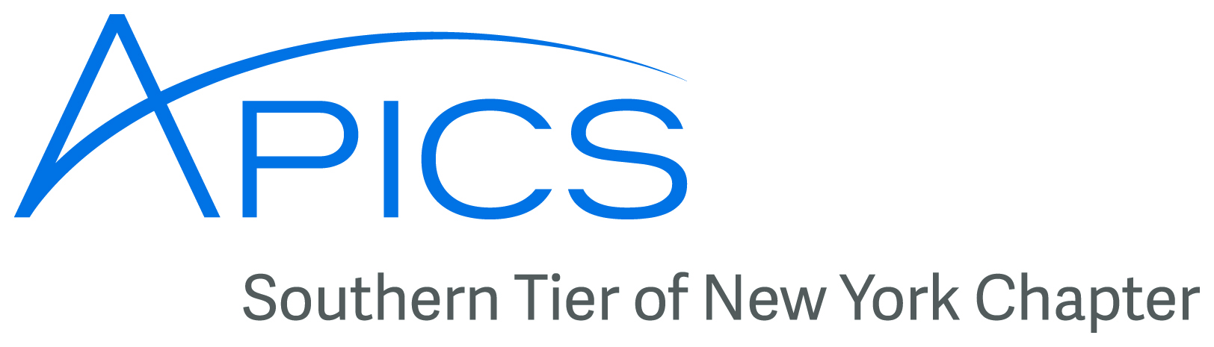
March 2016
www.stapics.org

Southern Tier APICS Update from Don Sheldon, Director of Education

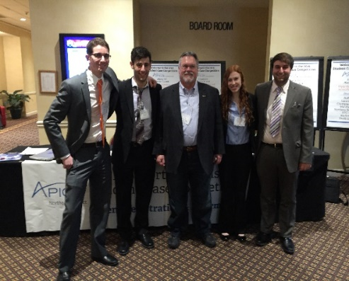
APICS Student Competition - Three teams from Binghamton University, sponsored by the Southern Tier APICS chapter, a professional operations and supply chain association, swept the supply chain problem solving competition in Albany this last weekend, 4-5 March. The APICS North East district holds this event each year with schools from all over the NE competing. Schools this year included: Rutgers, UConn, UMass Boston, UMass Amherst, SUNY Buffalo, SUNY Plattsburg and several others. Binghamton University’s undergrad teams, coached by Don Sheldon from Binghamton University, dominated the competition taking first, second and third places in the undergrad flight.
The winning team, L to R, Peter Mattar, David Berlin, Don Sheldon (coach), Kate Butera, Sam Clarke

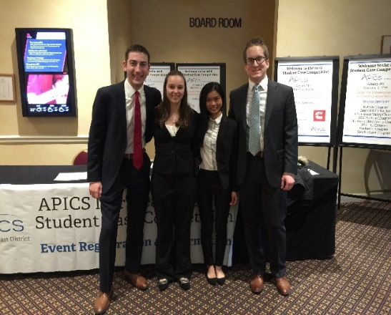
Third place team, L to R, Shawn Graber, Mackenzie Burnside, Gwen Ou, Jake Groezinger

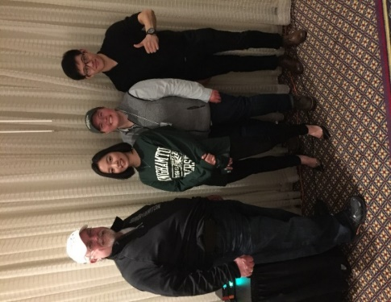
Because the first place Binghamton undergrad team scored higher than the first place grad team, the BU team also won an expenses paid trip to Washington, DC this September to compete in the APICS national competition. Said Don Sheldon, “I knew we had three very competitive teams going into this competition. They worked very hard since last October to prepare for this event and we obviously had a lot of fun this weekend as the work paid off.”
Second place team, L to R, Don Sheldon (coach), Bora Yoon, Amanda Martinez, Wei Xiao

APICS Course update—CPIM and CSCP – The next APICS CPIM offering will be BSCM (Basics of Supply Chain Management). It will be held on campus at SUNY Broome and will start 6 April. It will be held from 8 AM until noon for 5 Wednesdays. Registration can be accomplished by calling SUNY Broome at 607-778-5012.

Update from Don Sheldon, Director of Education (continued)

We are also offering a CSCP class on campus at SUNY Broome this summer. It will start Friday, 27 March from 8AM until noon and will go half days for 8 weeks. If any of you are interested, this is the time. We would sure like to hold our first CSCP certification prep course. This certification has gained great respect in the supply chain career path. Registration can be accomplished by calling SUNY Broome at 607-778-5012.
We will continue to offer training in whatever APICS subject areas that can generate appropriate interest. We need only 5 signed up to run any class. We can run multiple classes at the same time if the 5 minimum is met in each one. We also can also offer classes at your company’s facility if there is a need/desire. Just let us know.

Please contact dsheldon@sheldoninc.com if you have training needs you would like to see offered. This includes any of the CPIM courses as well as APICS Lean, APICS Principles, and/or APICS CSCP.

New for 2016! The APICS Logistics, Transportation and Distribution Certification (CLTD) program. – APICS just announced a new certification. New in 2016, APICS will be offering a comprehensive certification program focusing on logistics, transportation and distribution. Candidates completing the designation will be able to demonstrate their in-depth knowledge in:
- Logistics fundamentals  - Logistics strategy within the supply chain  - Logistics planning  - Capacity and demand management  - Order management  - Warehousing strategy  - Lean logistics  - Warehouse management  - Packaging  - Materials handling  - Transportation fundamentals including:  modes  routing  carrier selection  documentation | - Global logistics considerations including:  infrastructure  regulatory framework  customer  payment options  currency  tax  - Logistics network design including:  facilities location  layout  risk management  - Reverse logistics  - Sustainability and logistics
The new certification program, developed by APICS and subject matter experts will offer new courseware, self-study and instructor-led learning options and a single exam. The Southern Tier chapter plans to offer this as soon as materials become available. I will keep you posted.
Binghamton University’s student APICS Chapter update – The Binghamton University APICS Student Chapter, with over 600 members, is currently the largest student chapter on the planet! We are proud of their effort.
Thank you!
Don Sheldon
Director of Education
Southern Tier Chapter of APICS
dsheldon@sheldoninc.com


Have News, Events, or Items of Interest?
To have it included in next month’s newsletter
email it to jedestrada.writer@gmail.com by next
month’s B.O.D. meeting on April 13th.

___________________________________________________________________
Board of Directors 2016
President  Dave Gardner, CPIM  dgardner@emtmetals.com  Secretary  Debbie Unkel, CPIM  deb.unkel@raymondcorp.com  Director of Marketing & Publicity  Stephanie Ray  Sray02207@gmail.com  Director of Programming  Steve Stanchak, CPIM  sstanchak@stny.rr.com  Student Chapter Liaison  Westin Zeng  szeng2@binghamton.edu | Executive VP /Director of Finance  Steve Whited  steven.whited@acco.com  Director of Membership/Director of Chapter Standards/Director of Online Publication  Lee Schechter , CPIM  lschechter@stny.rr.com  Director of Education/2nd Director of  Student Relations  Don Sheldon, CFPIM CIRM CSCP  dsheldon@sheldoninc.com  Director of Communications  Jed Estrada  jedestrada.writer@gmail.com
Southern Tier APICS
PO Box 1107
Binghamton NY 13902-1107

